# Running The Daily Plan on the VA Laptop

## Start Here

The Daily Plan (TDP) has some required components which must be running before you can launch the Application. These components are:

1. MS SQL Server
2. MDWS Sun VirtualBox instance
3. Weblogic Application Server

### MS SQL Server

MS SQL Server runs as a service, and is started when you turn on the computer. The database has been loaded, but may need to be initialized to support software changes. This can be done using the ‘Reload Database’ icon.

### MDWS

The MDWS virtual instance should be launched first so that it can allocate all of the needed memory. This is started by selecting the Sun VirtualBox icon on the desktop or quick-launch bar, and selecting MDWS_BASIC, and clicking the Start button.

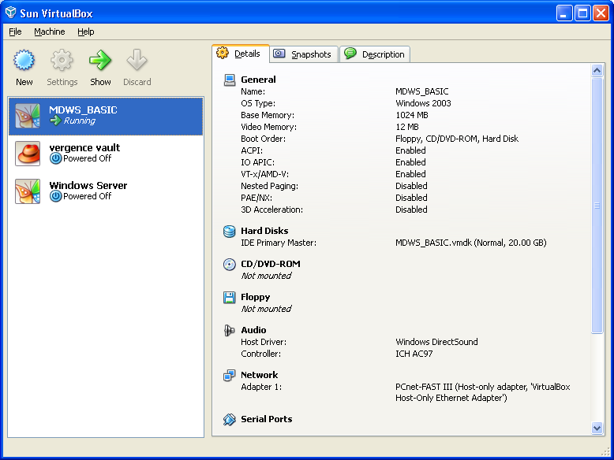

The VM will boot Windows Server 2003, and will show the Welcome To Windows dialog box once it is ready for requests. To verify that it is running, or you suspect that there is a problem, use the ‘EmrSvc Web Service’ icon, or use this URL in a browser: <http://192.168.56.12/mdws2.0.0/emrsvc.asmx>. If you try to launch MDWS when other processes are running, it may not be able to acquire enough memory to run, and you wil be presented with an appropriate error message. Simply close down other memory-intensive applications, and restart MDWS.

### Weblogic Application Server

This should be started using the ‘Start Admin Server for TDP’ icon. This will launch the Weblogic application server, and must remain running as long as The Daily Plan is being tested. It must be running when the Rebuild TDP process is run, or the script will fail. From time to time, especially if the Rebuild TDP script is run multiple times, it must be restarted. Simply close the window, and re-launch by clicking the ‘Start Admin Server for TDP’ icon.

## 

## Running The Daily Plan

There is a link on the desktop called ‘Patient Search The Daily Plan’. Clicking this will open a browser with the TDP application start page. To log into the application, use one of these A/V code pairs:

|  |  |  |
| --- | --- | --- |
| VHAINO321 | verify123. | TDP User |
| VHAINO111 | verify123. | TDP Admin |

The TDP User Role will be able to Search, View, Print The Daily Plan for patients, as well as save preferences. The TDP Admin will be able to do many more administrative functions, including: manage definition lookups, manage testimonials, set override date, view/manage TDP Users, including promoting other users to Admin.

## Vista

A set of common Vista applications including CPRS are installed on the laptop, and can be used to search and modify patient data. Note that to run CPRS, MDWS and Weblogic Server will most likely need to be shut down.